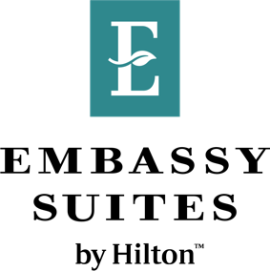

September 25th, 2024

«First_Name» «Last_Name»

«Address»

«City», «Prov_»

«Postal_Code»

Dear «First_Name»,

We are reaching out to inform you that, due to an internal computer-related error, you have been charged «Total_Bill» for your recent stay at Embassy Suites by Hilton. To compensate for this error, we have granted you a «M_45» discount. As a result, your new total, including the «HST» HST, comes to «Total_with_Tax_Refund», a 45% discount.

At Embassy Suites, we truly value your loyalty and deeply apologize for any inconvenience or stress we may have caused you. If you have any questions or concerns, please to not hesitate to reach out.

Thank you so much for your cooperation.

Sincerely,

Marcus Giancola

Communications Coordinator

Embassy Suites by Hilton Niagara Falls Fallsview